**AIM :** Design a flashing of led by using bluetooth.

**APPRATUS : 1** LED, breadboard, wires, arduino, resistor, bluetooth.

**CIRCUIT DIAGRAM** **:**

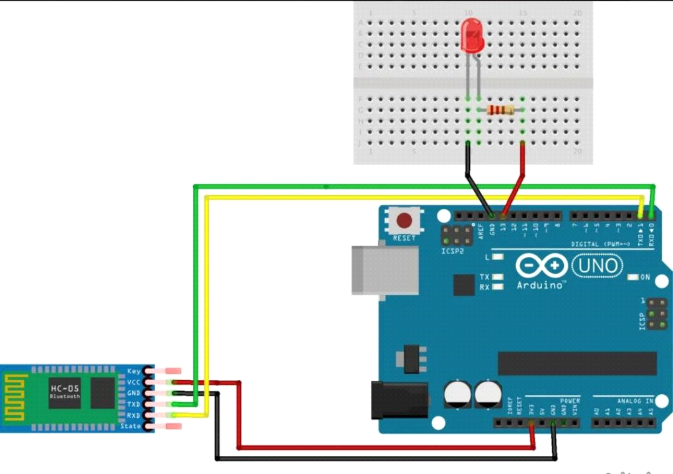

**THEORY** :

The LED has one p junction and n junction inside it, p is longer while n is shorter.

Breadbord have network of connection inside it.

**LEARNING & OBSERVATION :**

1. Learned how to connect the connection inside the breadboard.
2. Connection of LED in the breadboard and which is n side & p side of LED.
3. Learned how to connect resistor to arduino.

**PROBLEM & TROUBLESHOOTING:**

1. Connection of led in series and parallel was wrong.
2. Mistake in code uploading .
3. TX and RX should not be connected till the code is uploaded.

**LEARNING OUTCOMES**:

1. Connection of LED in series and parallel in breadboard.
2. connection of bluetooth with aruduino.